Experiment 8
Name: rohan ganesh ratne
Roll No: 24
Class: SE3

Aim: Building a Simple Counter App using React Hooks. Use React Hooks (useState,
useEffect) to manage state and side effects.

Code:

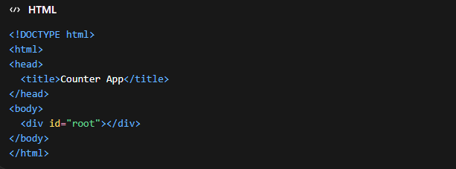
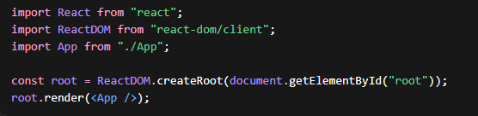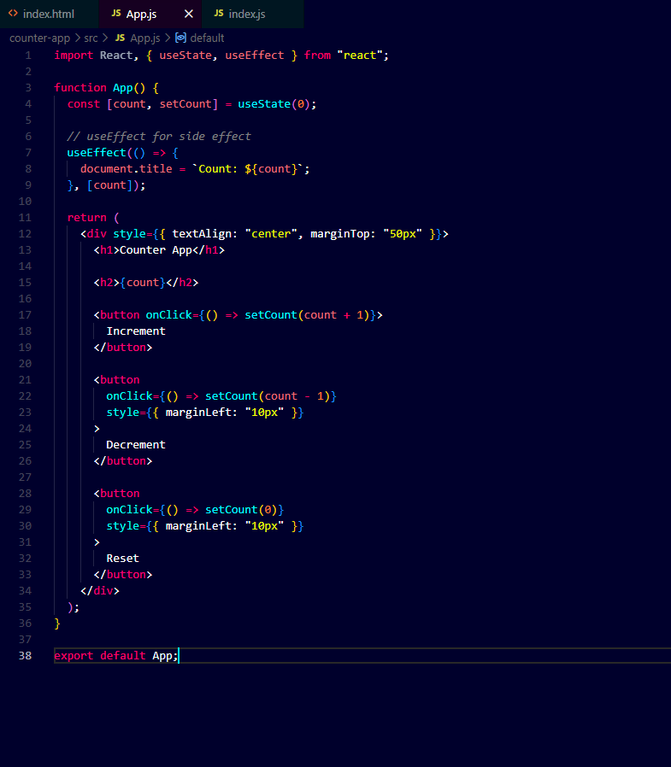
OUTPUT:

